pleasantville ayso Blue sombrero guide :Team Calendars

Introduction
In Summer 2017 AYSO nationally adopted the blue sombrero product to act as a registration/team management/ admin portal. As of fall 2017 there are still a number of non-intuitive functions in that portal and a series of how to guides is being produced to help users navigate the noise.
This document focuses on Team Calendars

basic Setup
In order to send emails form the system you need to be assigned as either an assistant or head coach on a Team.
The first step is to access your teams "Team Page"
These can be found here
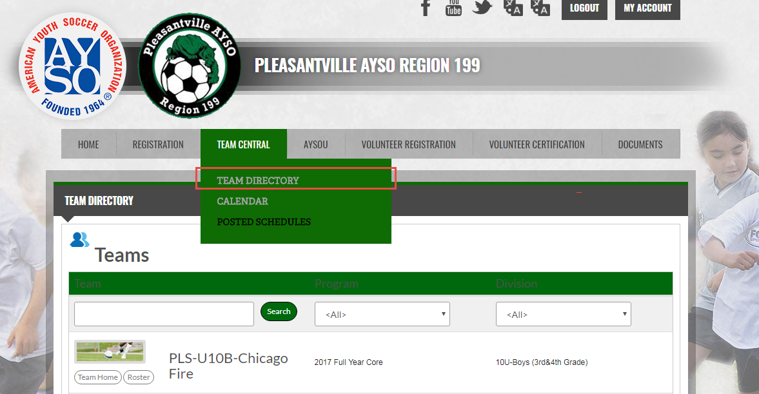
Find your Team and select Team Home

How to add an event
Select the Team Calendar and go to Create Event
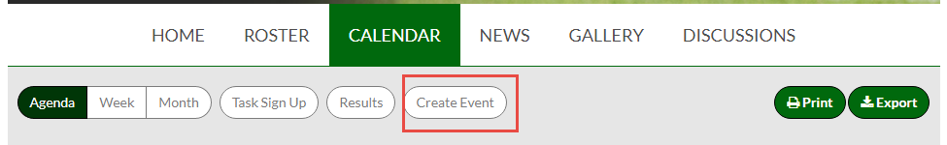
Once you do this you can add in the details , here I'm setting up practices for the Earthquakes. Note that as of September 2017 Games are not automatically added to the calendar. If a coach chooses to add games it is imperative they keep the Team Calendar in sync with the master game calendar (in quickbase as of September 2017)
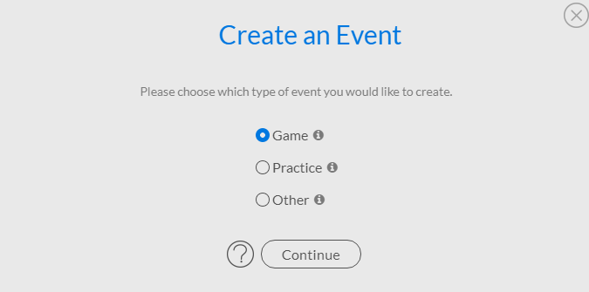
The form itself is pretty self-explanatory (see screenshot) , with a few cool features : 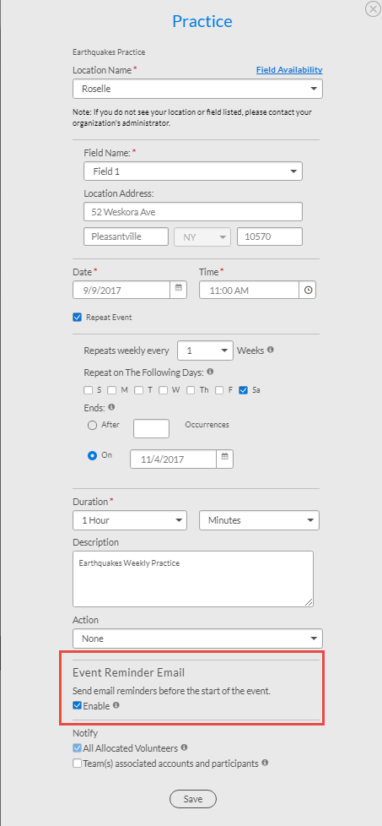
- For repeat events its best to setup the full sequence , then delete any holidays/non practice days
- Sending an Auto reminder is a good idea
- The action field is interesting and drives the notification text.
- The notify section is important – You want to make sure you target the correct audience (i.e. when first setting up a schedule you probably only want volunteers, when rescheduling a game you want to notify volunteers and participants

Editing the Agenda
Once this is done you can look at the different calendar views :
Agenda is the one that makes most sense :
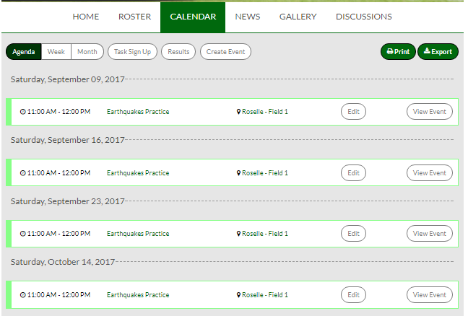
Here you can quickly edit events which will trigger the same screen as a new event but allow you to update or cancel.

Advanced features
Task Sign Up
Once you have events scheduled , you can add tasks to them and have people sign up for them, you will also see alist of all tasks that you have signed up for. This is great for managing Snacks etc and having a parent verify they have signed up for them :
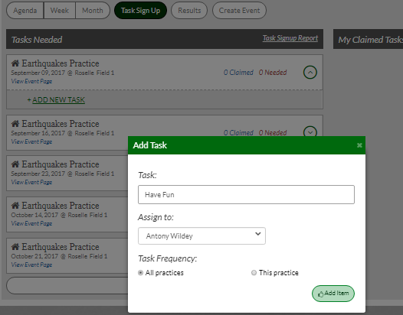
Calendar Sync
You can sync the team calendar to your apple/android/Microsoft calendar by clicking export in the top right and following the instructions :

